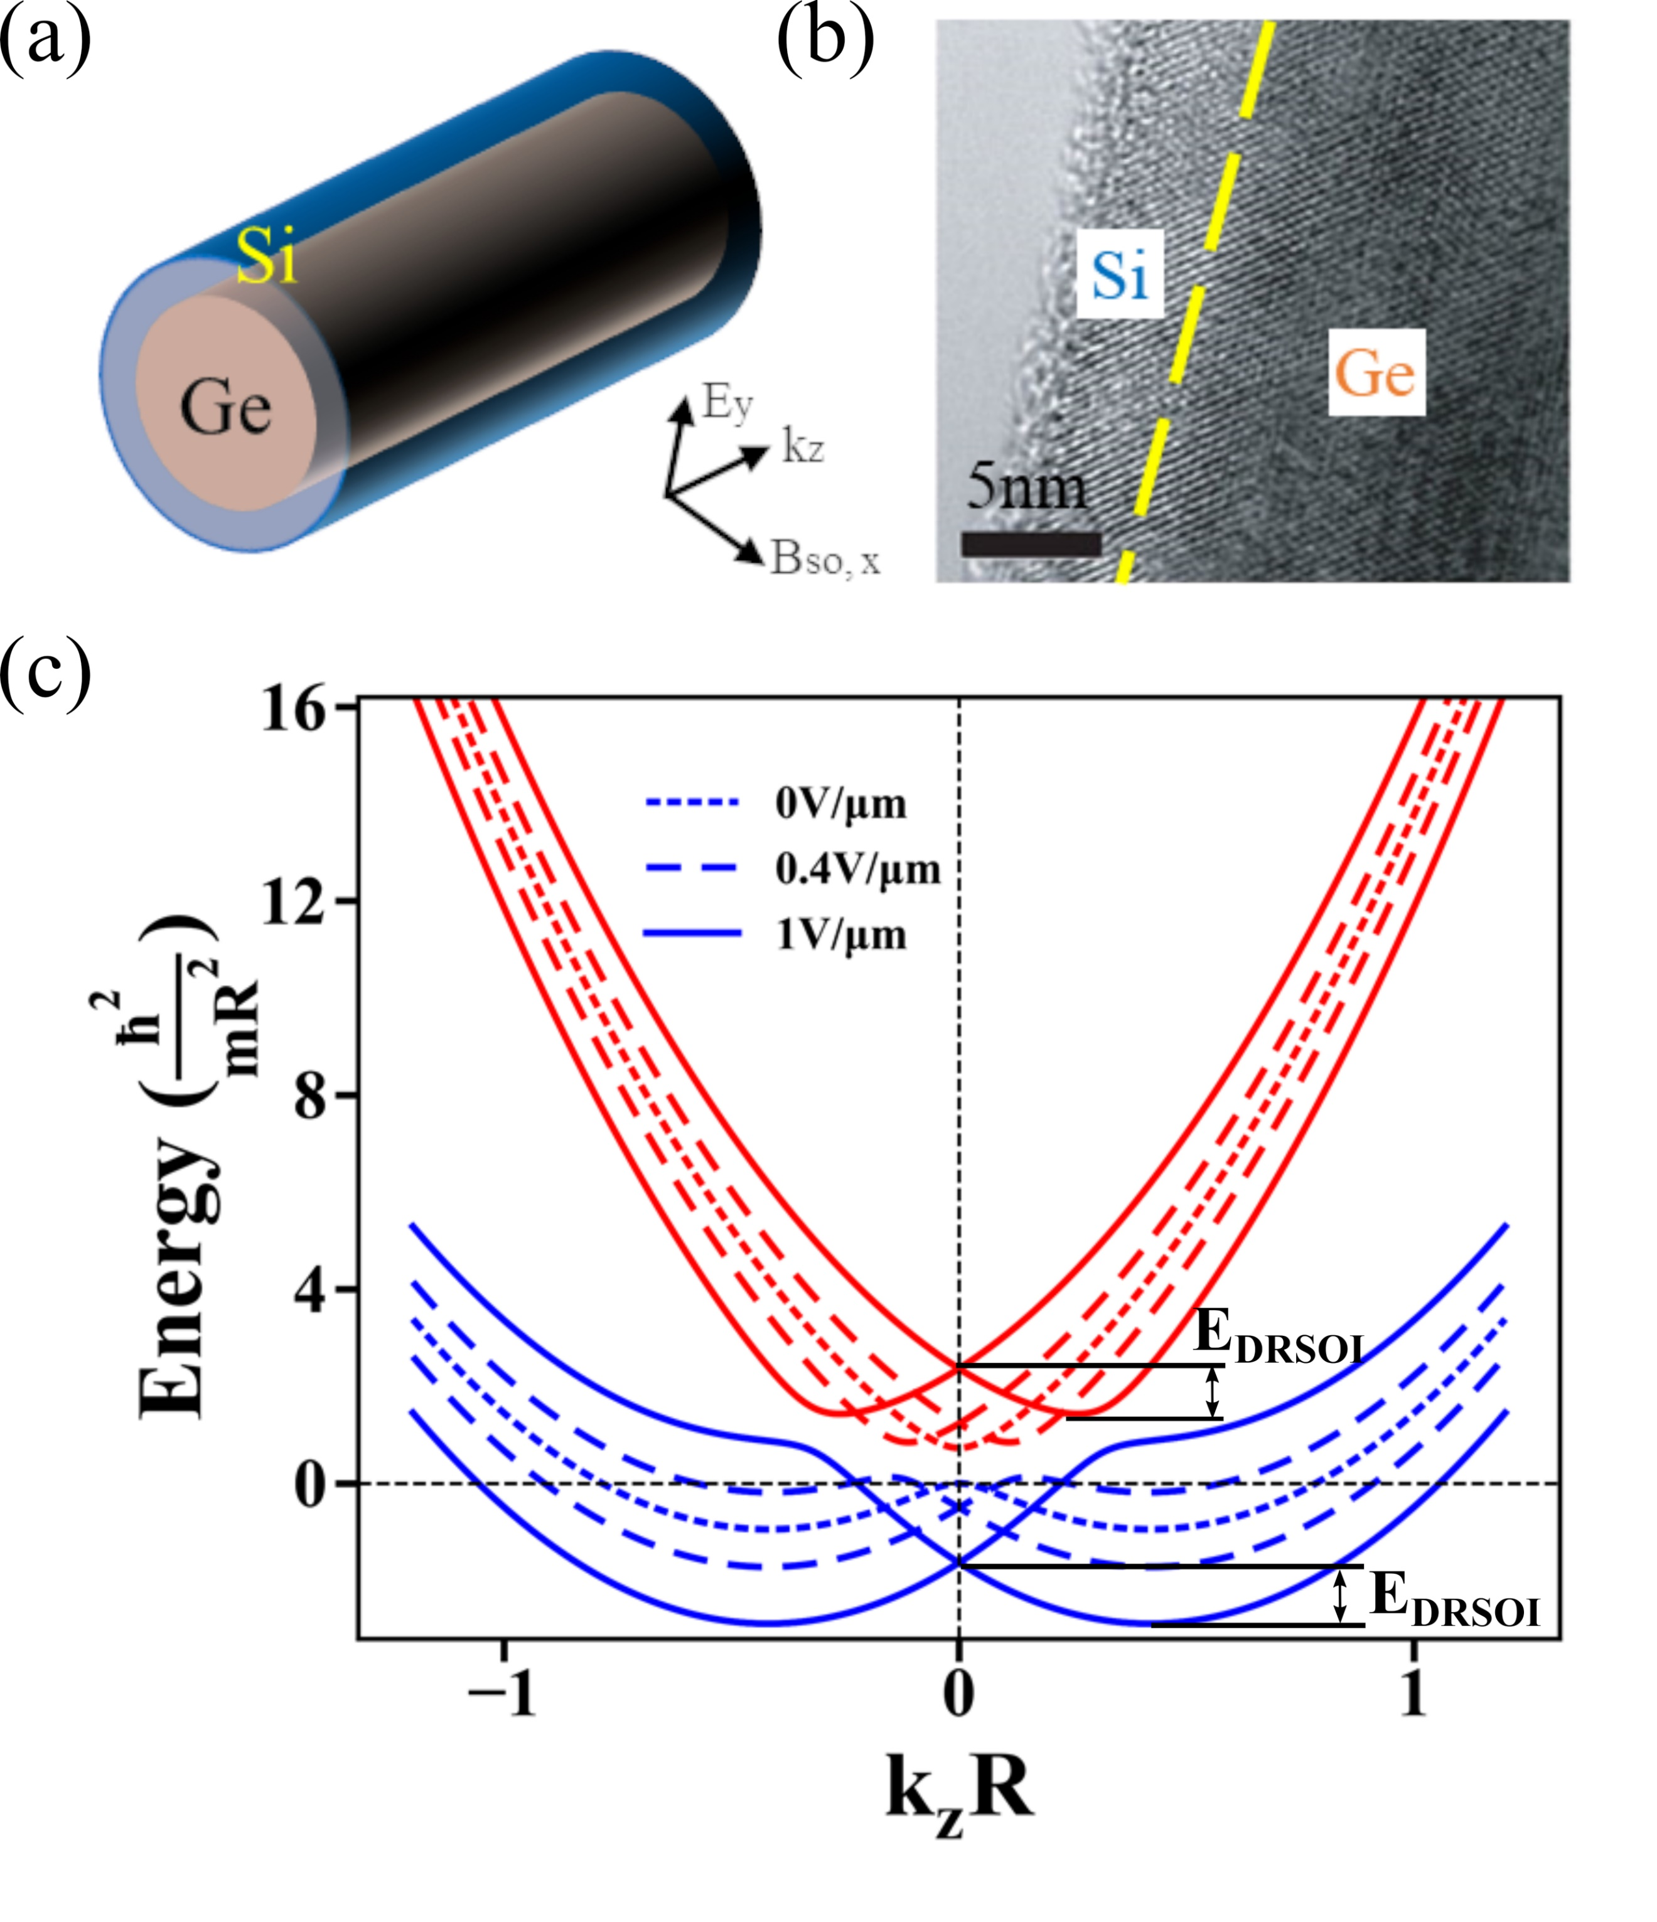

**Fig. 1.** Germanium/silicon (Ge/Si) core/shell nanowire. (a) Schematic drawing and (b) transmission electron micrographic (TEM) image of a Ge/Si nanowire. Single crystalline structures of Si shell and Ge core are distinguished in (b). Carrier momentum $k$ is confined in $z$-direction along the wire axis. Electric field $E$ (in $y$-direction) is applied transversely to the wire and the induced effective spin-orbit field $B_{SO}$ is perpendicular to both $E_{y}$ and $k$. (c) Horizontal splitting of the low-energy hole spectrum induced by $E_{y}$ in the $E-k$ diagram. The spin splitting energy $E_{DRSOI}$ is indicated on different orbital states in (c).

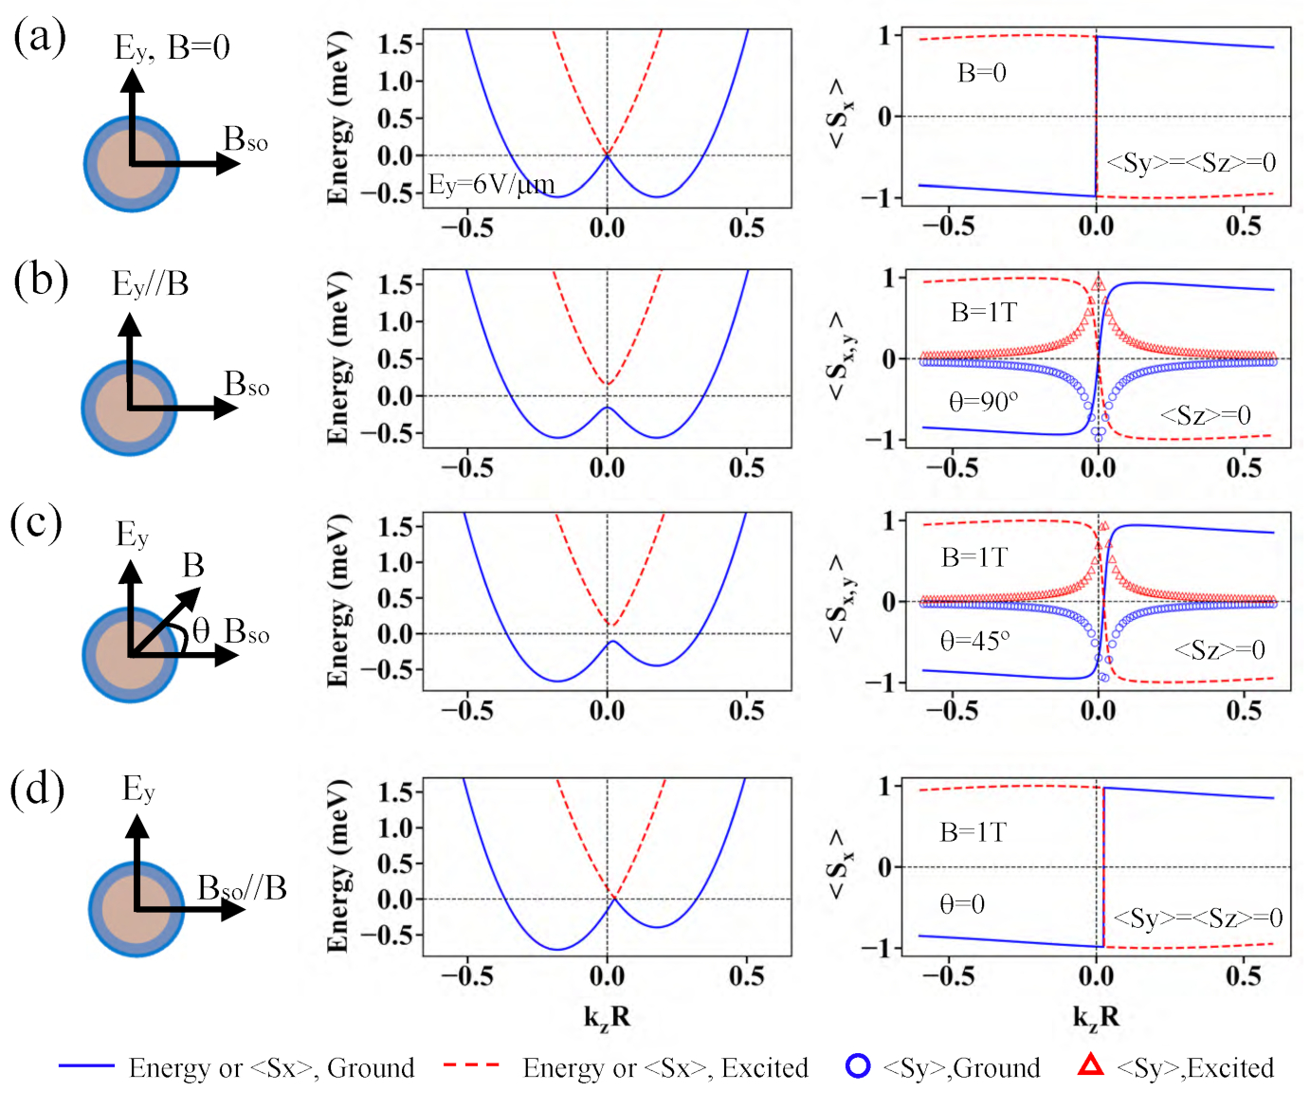

**Fig. 2.** Splitting of the lowest valence band with a fixed external electric field strength *V/m* and a varied external magnetic field $B$ applied to a Ge/Si NW with $R_{Ge}=5$ *nm* and a strain induced energy gap $∆=20$ *meV*. $B_{SO}∝E_{y}×k_{z}$ is linearly proportional to the strength of the applied electric field. The relative orientation angle $θ$  between external magnetic field $B$ and $B_{SO}$ determines the valance band dispersion relation, Zeeman splitting and spin state, as compared by the numeric calculations of eigenenergies and expected spin projection <Sx,y,z> with (a) $B=0$, (b) $B=1$ *T*, $θ=90°$, (c) $B=1$ *T*, $θ=45°$, and (d) $B=1$ *T*, $θ=0°$. As $E_{y}$ and $B$ are both perpendicular to the wire, *<Sz>* is always zero throughout.

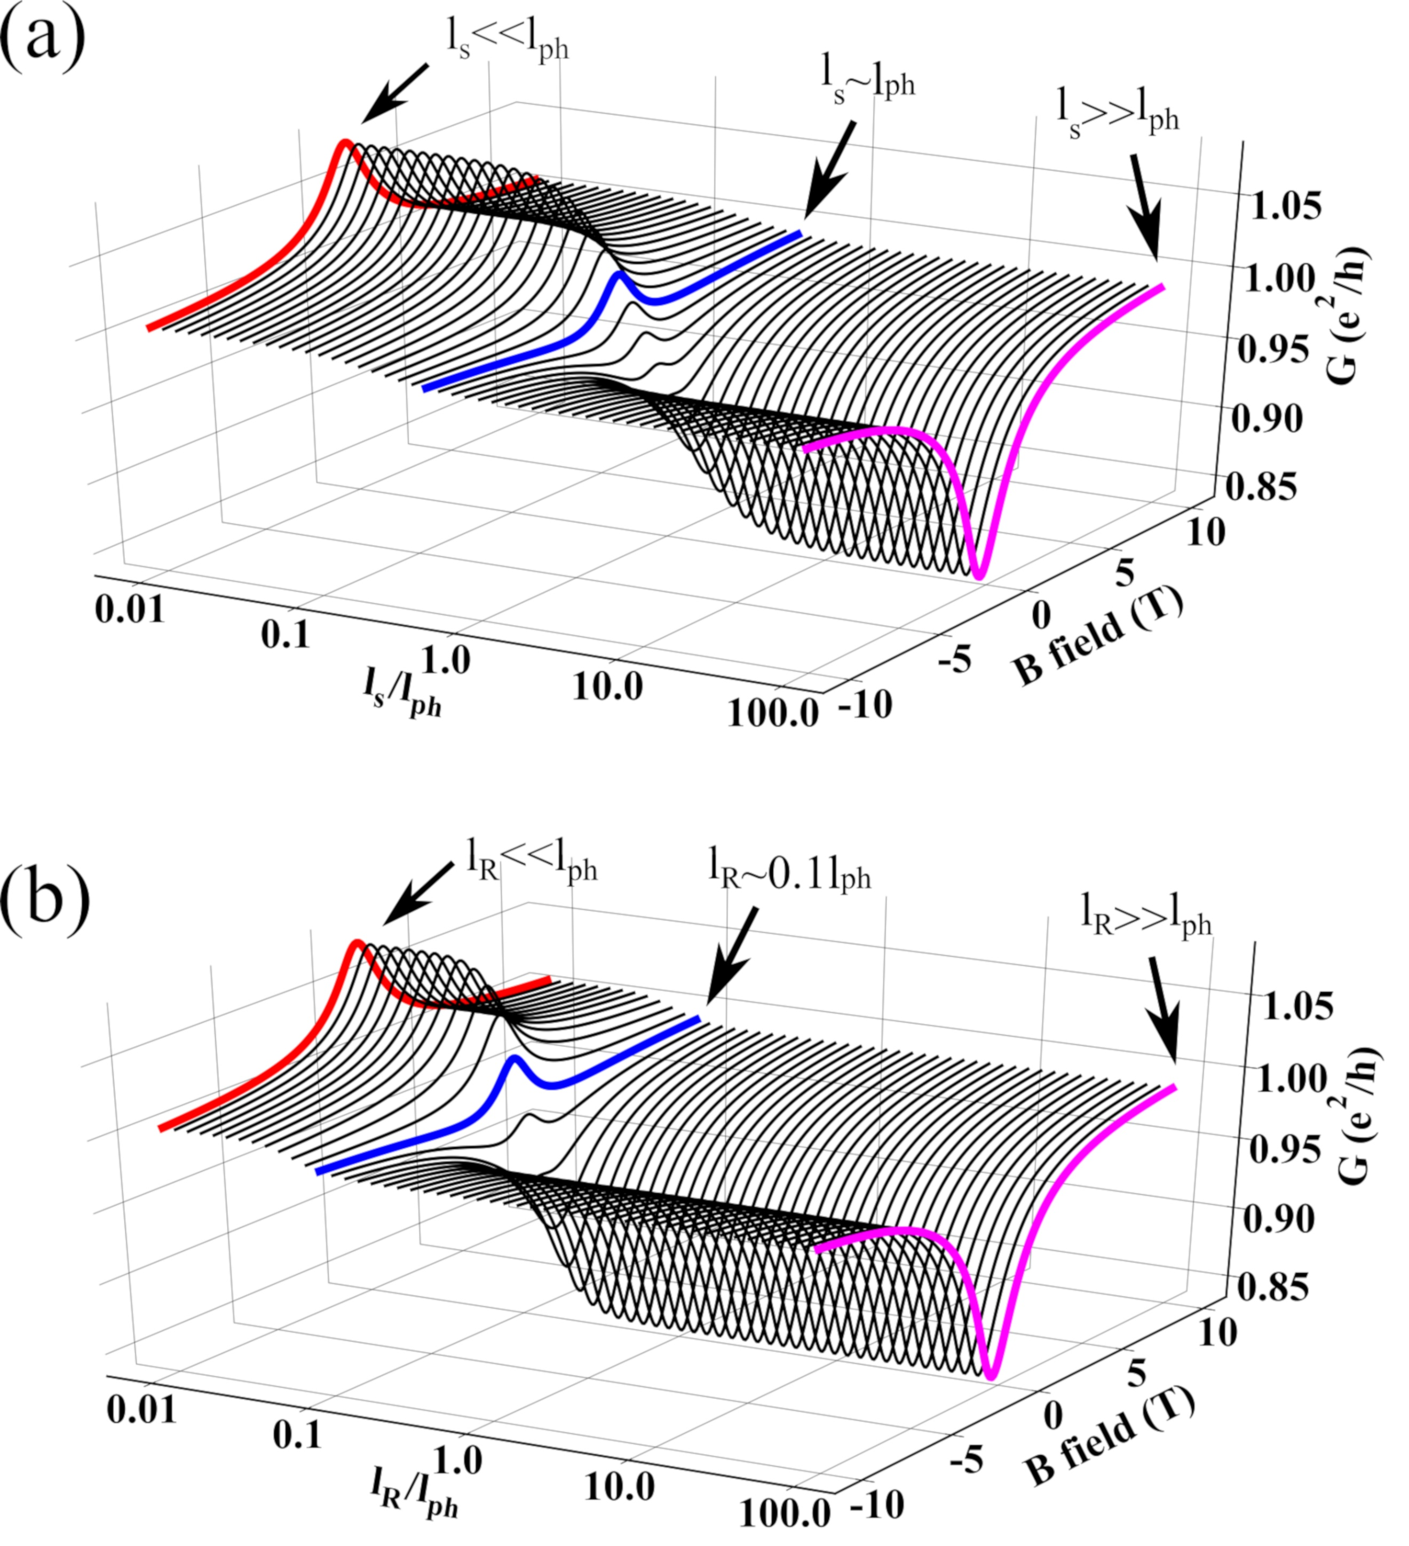

**Fig. 3.** Weak-antilocalization in a Ge/Si nanowire without (a) and with (b) the consideration of geometrical confinement on spin relaxation. The evolution of calculated magnetoconductance (MC) as a function of (a) $l_{S}/l_{ph}$ and (b) $l_{R}/l_{ph}$ using a one-dimensional model are compared. The NW radius $R_{Ge}$ is $10$ nm and length  *m*. The mean free path $l_{e}=20$ nm and $l_{ph}=100$ nm are assumed for these calculation.

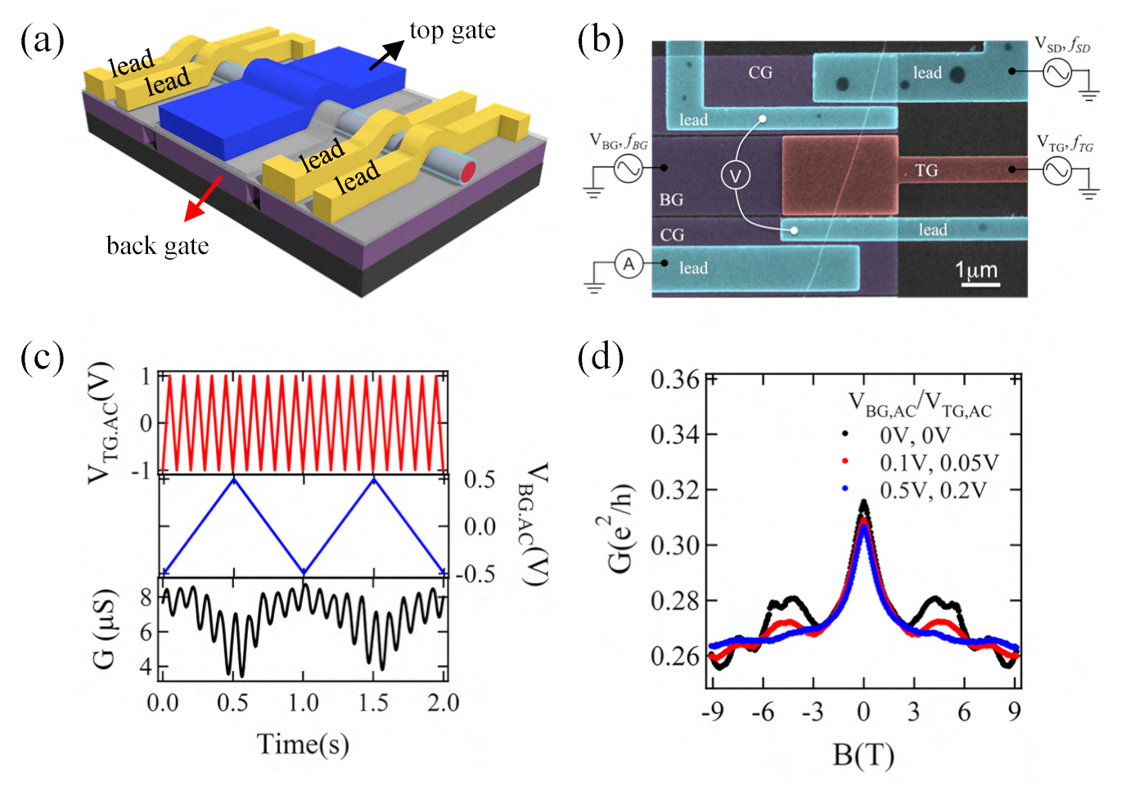

**Fig. 4.**  Device architecture and measurement method. (a) A schematic drawing of a dual electrical gated device. (b) False color scanning electron micrograph (SEM) with circuit diagram. (c) Real time signals of *TG* (red), *BG* (blue) *AC* voltages and the measured differential conductance *G* (black) in a two second span. The recorded $G$ of each data point in the magnetic transport is the average of all signal collected in two seconds. $f_{TG,AC}=10$ *Hz*and $f_{BG,AC}=1$ *Hz* (d) Comparison of *G* as a function of magnetic field with different ${\text{V}}_{\text{TG,AC}}$ and ${\text{V}}_{\text{BG,AC}}$. By averaging the MC with enough AC gate voltage amplitude, the universal conduction fluctuation (UCF) can be dramatically suppressed. Reprinted with permission from Ref. [11]. Copyright 2017 IOP Publishing.

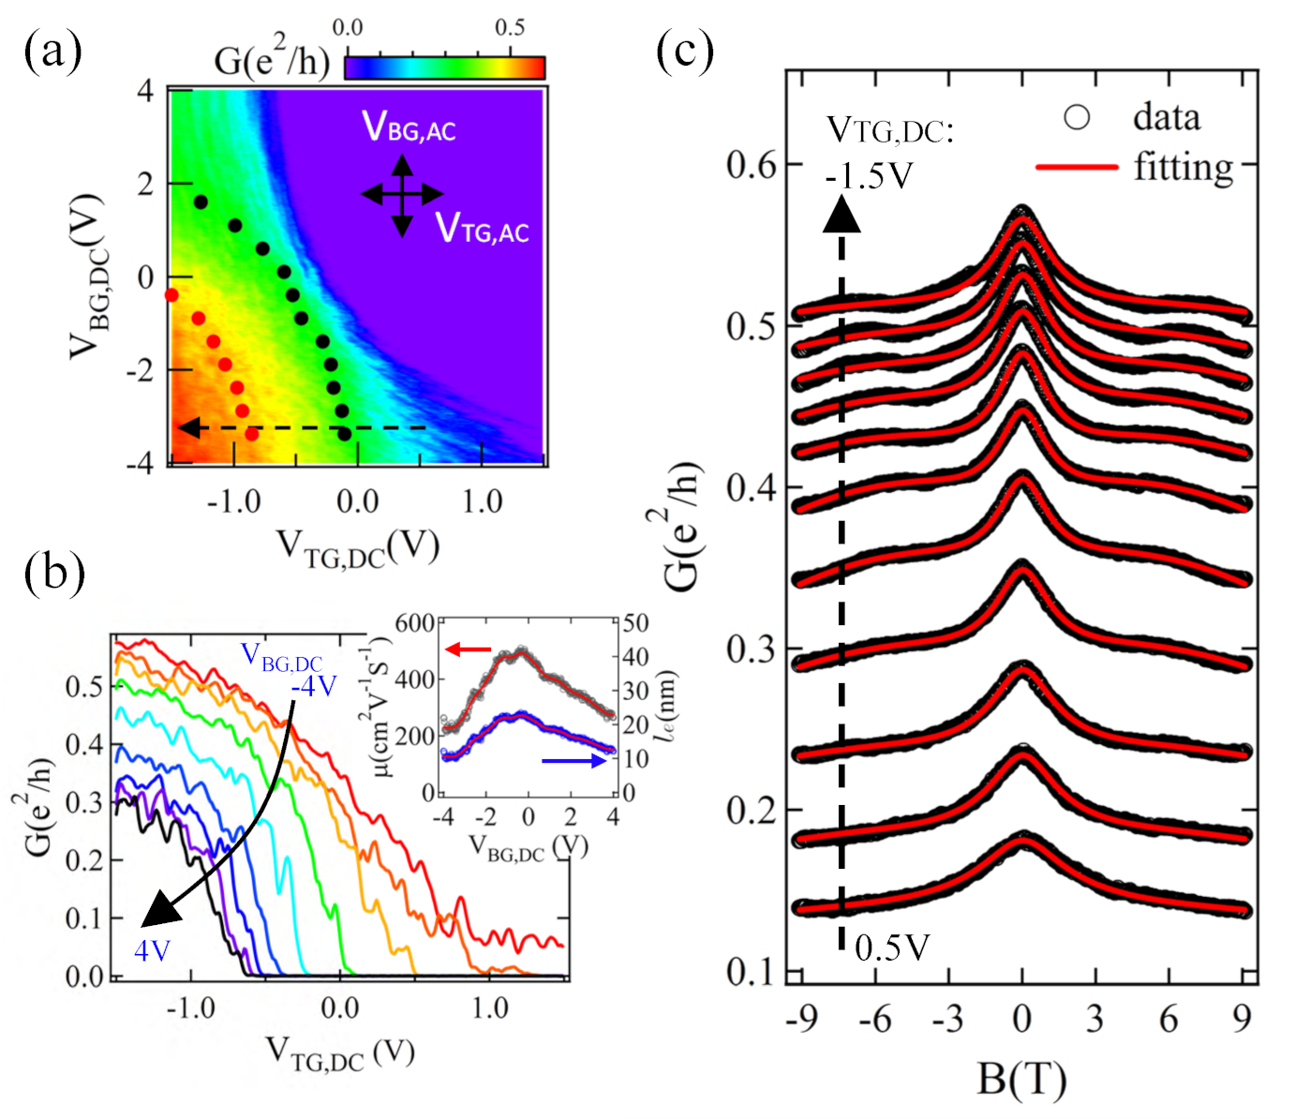

**Fig. 5.** Characterization of the electrical and magnetic conductance. (a) Differential conductance G of a  *m* long Ge/Si device as a function of the TG and BG DC voltage offset, where the red and black dots indicate the gate voltage setting with *G* being kept constant at $0.5e^{2}/h$ and $0.25e^{2}/h$, respectively. (b) line cuts of *G* in (a) as a function of ${\text{V}}_{\text{TG,} \text{DC}}$ with ${\text{V}}_{\text{BG,} \text{DC}}$ varied from $-4$ *V* to $4$ *V* with $0.5$ *V* per step. UCF is observed on each $G$ trace while the AC gate voltages are not applied. The inset shows the gate dependence of the extracted mobility (black circles) and mean free path (blue circles). The red solid line is the smooth to guide the eye. (c) MC traces with ${\text{V}}_{\text{TG,} \text{DC}}$ varied from $0.5$ *V* to $-1.5$ *V* with $0.2$ *V* per step and ${\text{V}}_{\text{BG,} \text{DC}}$ fixed at $-4$ *V*. Black circles represent the experimental data, red solid lines are the fits using the input parameters $l_{e}$ and $\text{μ}$ extracted from the inset of (b). Reprinted with permission from Ref. [11]. Copyright 2017 IOP Publishing.

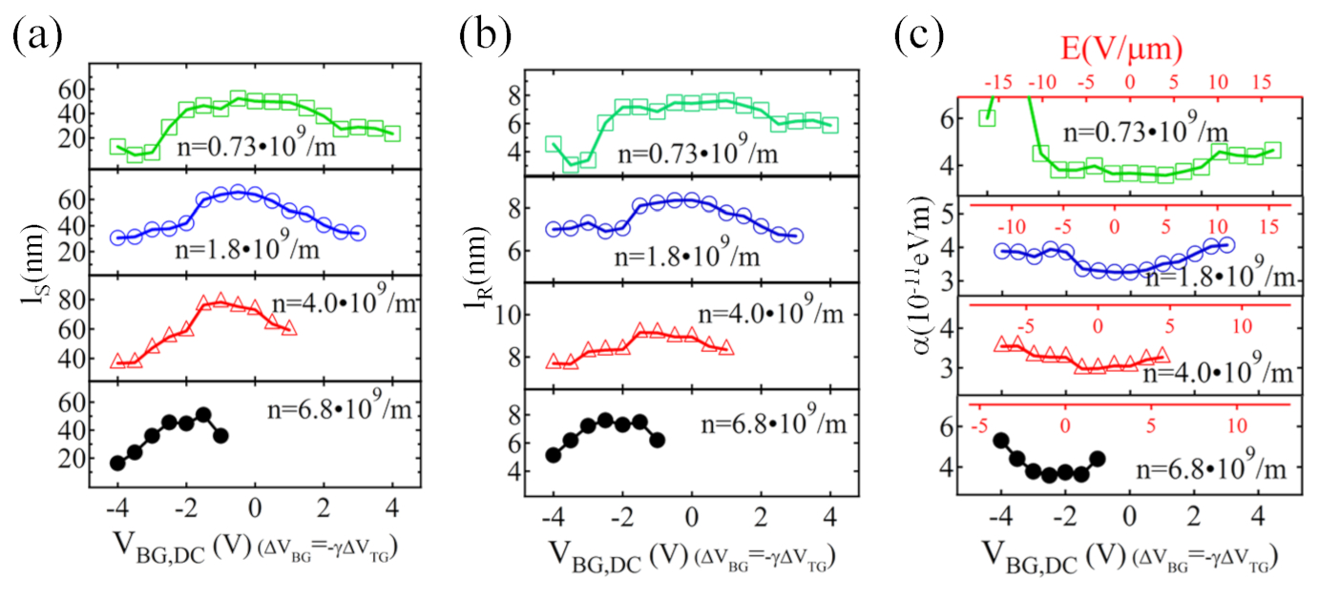

**Fig. 6.** Electrical modulation of spin-orbit interaction. (a) spin scattering length $l_{s}$, (b) spin orbit length (or coherent precession) length $l_{R}$, and (c) Rashba coefficient $\text{α}$ as a function of the asymmetric gating. In (c) the equivalent electrical field across the nanowire is plotted on the inset top axis. Reprinted with permission from Ref. [11]. Copyright 2017 IOP Publishing.

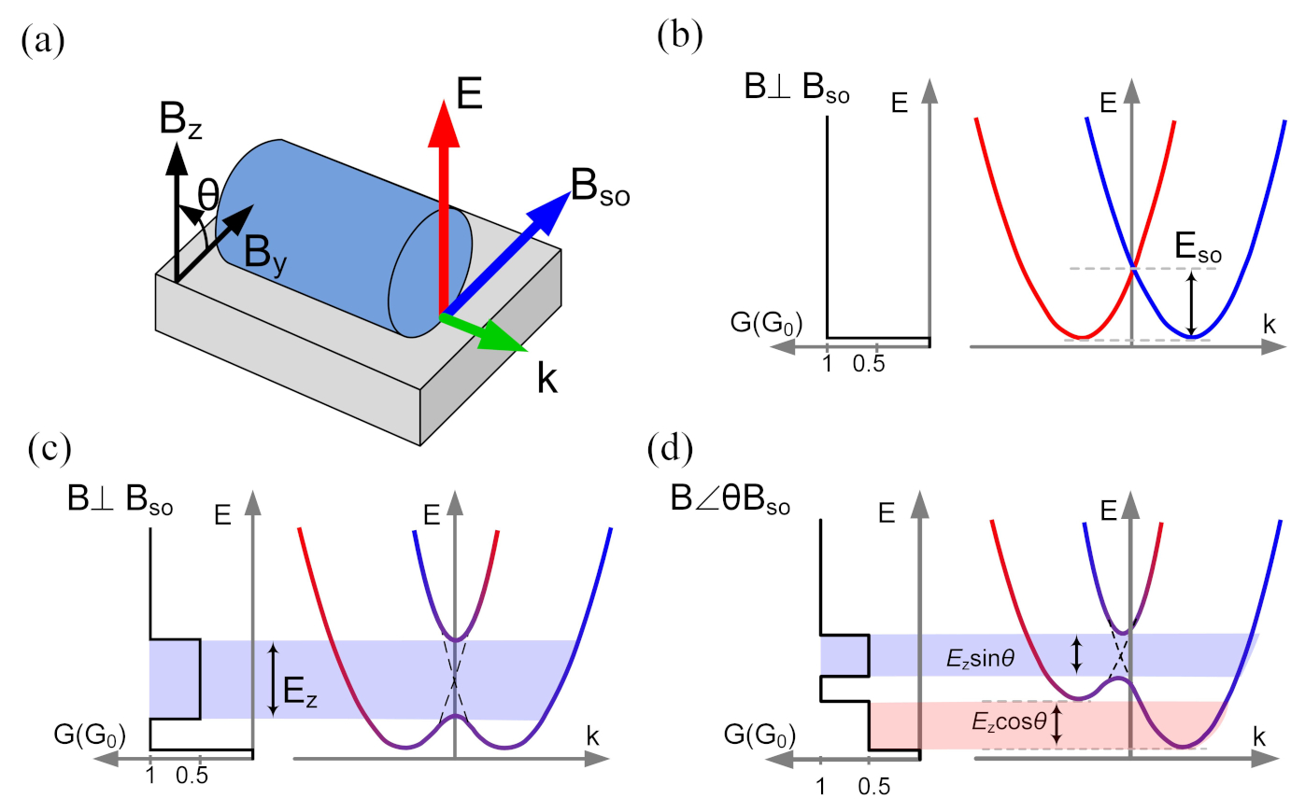

**Fig. 7.** Transport characteristics with helical state.(a) An illustration showing a nanowire device with a Rashba spin-orbit field $B_{SO}$ perpendicular to the wave vector $k$ and the electric field $E$; Energy dispersion of two lowest spin sub-bands with SOI and the corresponding conductance measurement (b) without magnetic field, (c) in a $B$-field perpendicular to SOI field $B_{SO}$, (d) in a $B$-field with an angle to $B_{SO}$.

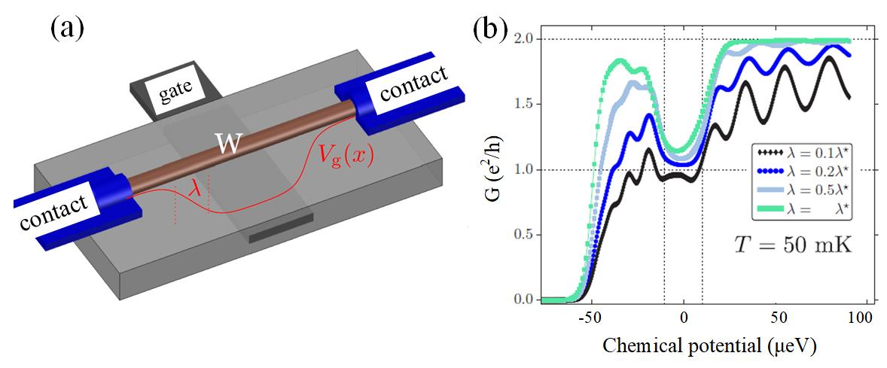

**Fig. 8**. (a) Schematic of a nanowire with two contacts. An underlying gate is utilized to tune the chemical potential in the center of the wire. The chemical potential varies from the contacts to the center of the wire by an onset potential length of $λ$. (b) Simulated conductance behavior in a nanowire as a function of the chemical potential considering the superimposed Fabry-Pérot interferences with varied geometries and gate onset potential length in units of the optimum optimal value $λ^{*} = 2ħv_{F}/E_{z}$. The potential difference between the contacts and wire is fixed at $0.5$ meV. Reprinted with permission from Ref. [27]. Copyright 2014 American Physical Society.

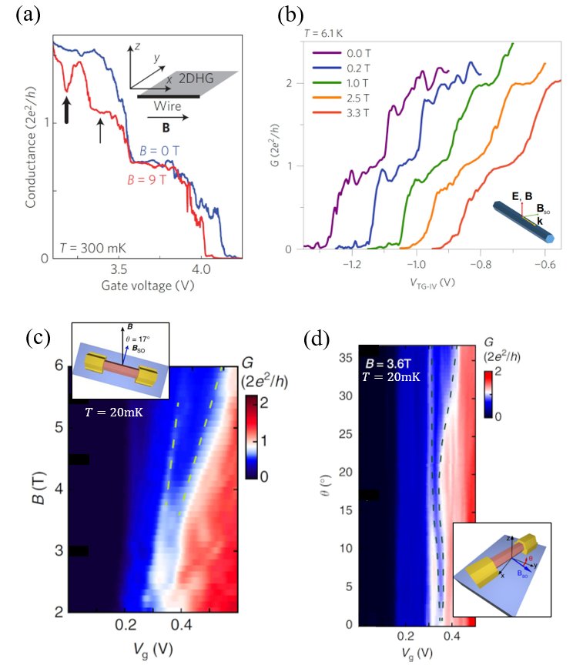

**Fig. 9.** Signatures of helical state observed in a variety of group III-V semiconductors. (a) Quantized conductance measurement in the GaAs hole nanowire at $300$ *mK* with the re-entrant feature residing on the second conductance plateau in the magnetic field applied along the wire as shown by inset. (b) Expanded re-entrant conductance feature measured at $6.1$ *K* in an InAs nanowire in the increased magnetic fields applied perpendicular to the wire as shown by inset. (c) Conductance measured in the InSb nanowire at $\sim 20$ *mK* as a function of gate voltage and an external magnetic field applied with an angle to $B_{SO}$ as shown by inset. Dashed green lines give the eye guide to the linear expansion of the re-entrant conductance feature. (d) Conductance measured in the same InSb nanowire device of (c) in the rotated magnetic field of $3.6$ *T* from $B_{SO}$ by $θ$ as shown by inset. The nonlinear evolution of re-entrant conductance feature is marked by the dashed lines. Reprinted with permission from (a) Ref. [28]. Copyright 2010 Springer Nature. (b) Ref. [29] Copyright 2017 Springer Nature. (c) and (d) Reproduced from [30] by Kammhuber J *et al.* licensed under CC BY 4.0.

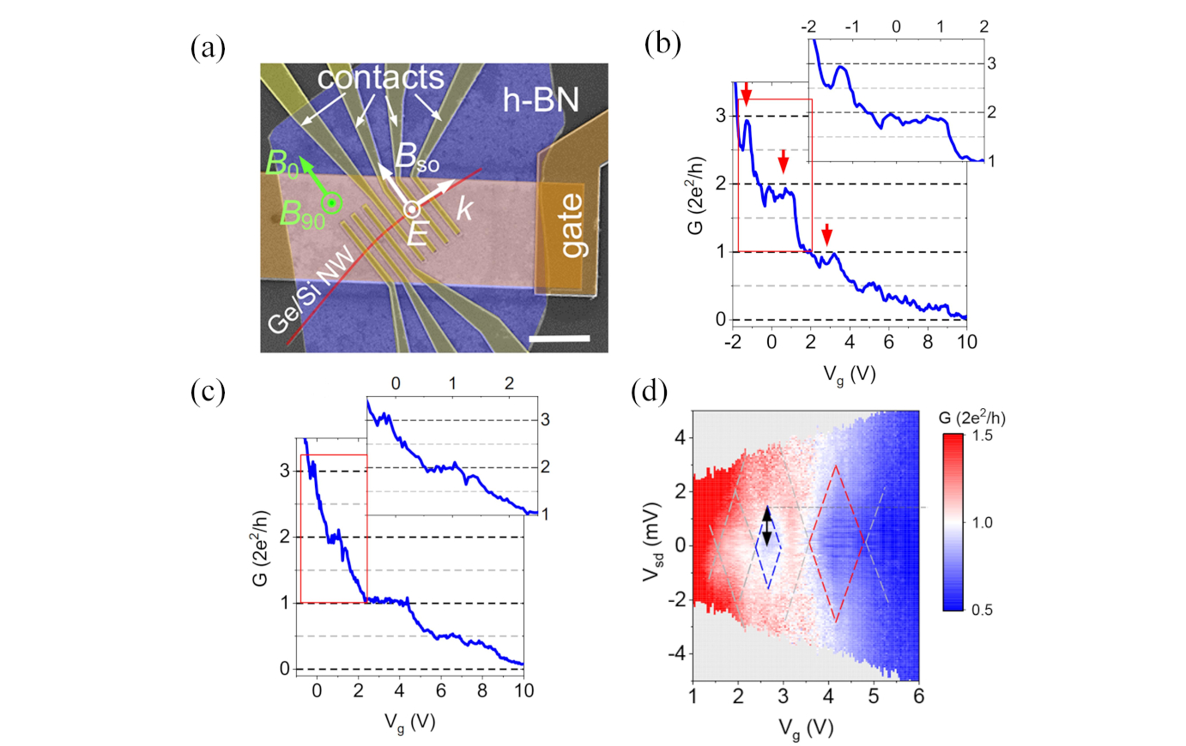

**Fig. 10**. Signatures of helical state observed in a Ge/Si nanowire. (a) False color SEM of the Ge/Si device for helical state detection. A Ge/Si NW (red) with Ti/Pd contacts (yellow) is located on a gold bottom gate (orange) with h-BN (blue) as the dielectric layer. Rashba spin−orbit field $B_{SO}$ is perpendicular to $k$ and $E$. The scale bar is $2$ μm. (b) and (c) Conductance traces with no B-field application measured at $7.5$ *K* without DC bias, and at $12$ K with $1$ mV DC bias, respectively. The red arrows indicate the re-entrant conductance features. Insets show the zoomed-in details of the red boxes. (d) voltage bias spectroscopy of conductance measured without magnetic field. The blue dashed lines indicate the perimeter of the helical gap region. The red dashed lines indicate the perimeter of the $e^{2}/h$ plateau at zero field. Reprinted with permission from Ref. [12]. Copyright 2018 American Chemical Society.

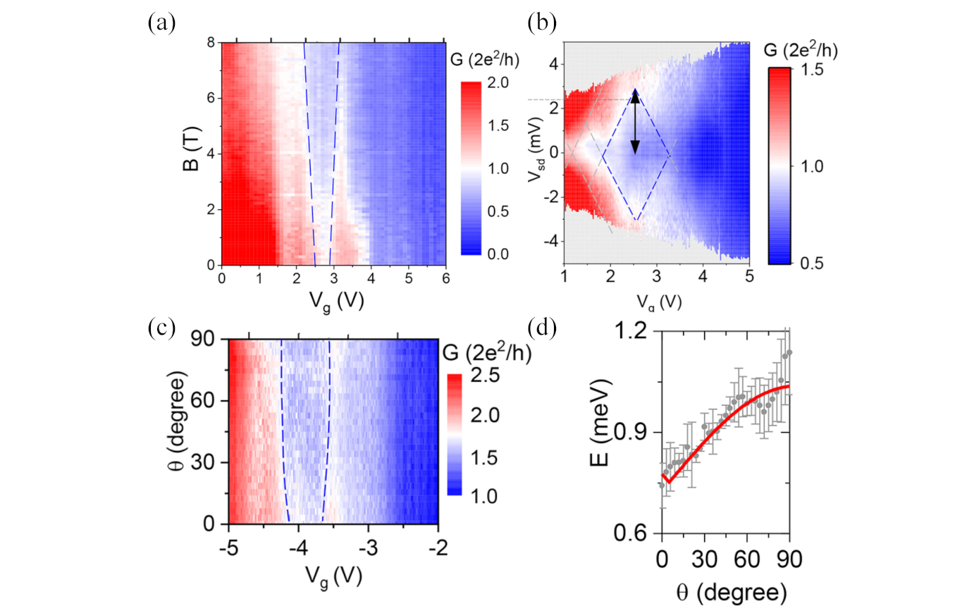

**Fig. 11.** Linear and angular dependence of helical energy gap on the external magnetic field. (a) Quantized conductance of the first conduction mode measured in the Ge/Si nanowire as a function of ${BB}_{SO}$. The linear expansion of the re-entrant conductance is marked with blue dashed lines. (b) voltage bias spectroscopy of conductance measured at $8$ *T* field applied normal to $B_{SO}$. The blue dashed lines indicate the perimeter of the helical gap region. (c) Quantized conductance at $B = 6$ *T* as a function of tilt angle $θ$ to $B_{SO}$. The evolution of the re-entrant conductance feature is highlighted using the blue dashed lines. (d) Helical gap energy (gray dots) extracted from (c). Red solid line is the fit using $E ∝ E_{z}·|sinθ|$. Reprinted with permission from Ref. [12]. Copyright 2018 American Chemical Society.

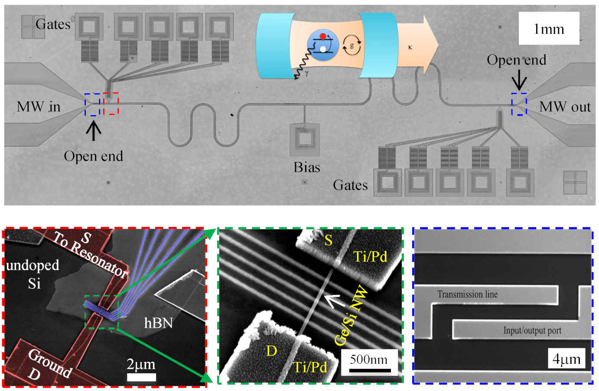

**Fig. 12.**  Optical and SEM images of a nanowire-resonator hybrid device. Upper: An optical micrograph of a typical superconducting MoRe transmission line resonator with two nanowire quantum dot devices near both open ends. Inset is a carton illustrating a TLS-cavity interaction system. The DC wires are connected to the bonding pads through on-chip LC filters. Bottom: Magnified SEM images of a gated nanowire device on top of exfoliated h-BN substrate, further zoomed nanowire and gates, and the input/output coupler of the resonator, respectively.

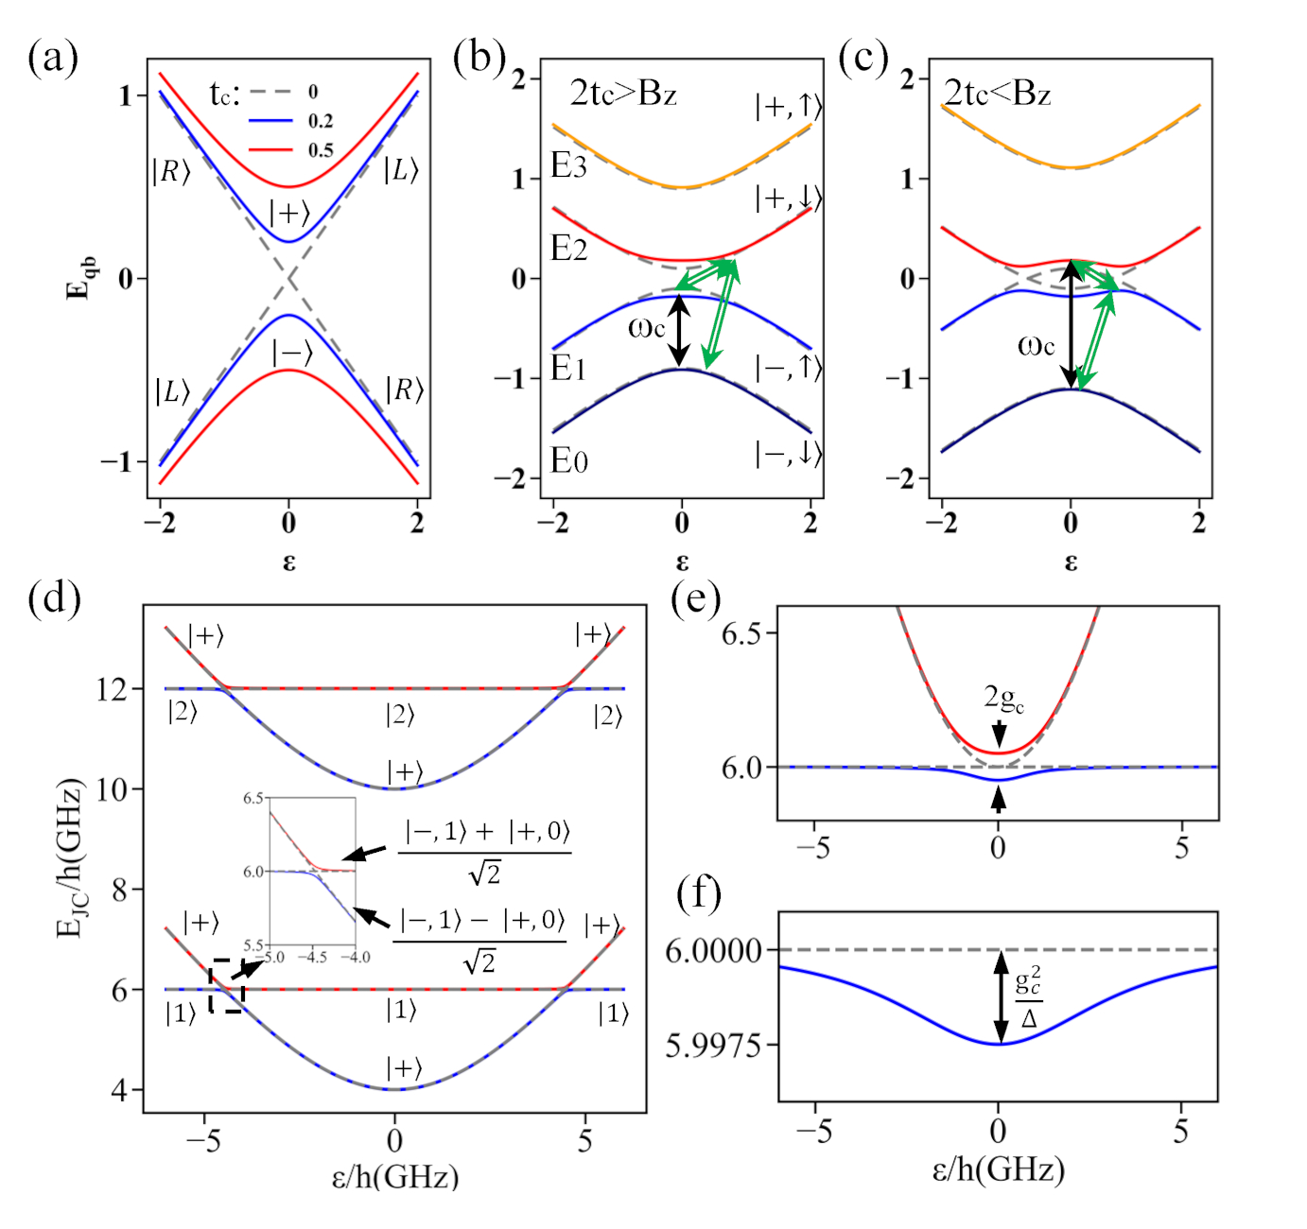

**Fig. 13.** Simulation of lowest energy level spectrum of various quantum system. (a) Energy levels of a charge qubit formed in a DQD as a function detuning energy $ε$ and tunnel coupling strength $t_{c}$. Excited/ground orbital states are denoted as $\left.\text{|±}\right\rangle$. Splitting of orbital states into a four-level system is present with an applied magnetic field of (b) $B_{z}<2t_{c}$ and (c) $B_{z}>2t_{c}$. The orbitals with spin ↑, ↓ are denoted as $\left.|±, ↑(↓)\right\rangle$. $t_{c}=0.5$, $B_{SO}=0.3$, and $B_{z}=0.8$ in (b) and $1.2$ in (c) are used for simulation. Dash line corresponds to $B_{SO}=0$. In (a-c) the simulation parameters are in energy unit for simplicity. As illustrated by black arrows ($\left.|-, ↓\right\rangle$ ↔ $\left.|-, ↑\right\rangle$, etc) in (b) and (c) a spin embedded in a resonator couples to a photon when photon energy $ω_{c}$ is close to $B_{z}$. Simply speaking, the spin-photon interaction is realized as a combination of the electric-dipole coupling induced orbital transition (green arrows, $\left.|-, ↓\right\rangle$ ↔ $\left.|+, ↓\right\rangle$, corresponding to $E_{0} E_{2}$ in (b) and $E_{0} E_{1}$ in (c) at $ε$ close to zero, respectively) and spin-orbit hybridization between the closest orbital levels (green arrows, $\left.|+, ↓\right\rangle$ ↔ $\left.|-, ↑\right\rangle$, corresponding to $E_{1} E_{2}$ in both (b) and (c)). For a charge qubit coupled to a resonator, the lowest eigenenergy level spectrum as a function of qubit detuning $ε$ is simulated by a Jaynes-Cummings model under the condition (d) $2t_{c}/h<f_{c}$, (e) $2t_{c}/h=f_{c}$, and (f) $2t_{c}/h>f_{c}$. In (d-f) the simulation parameters are similar to the practical values of the measured device.

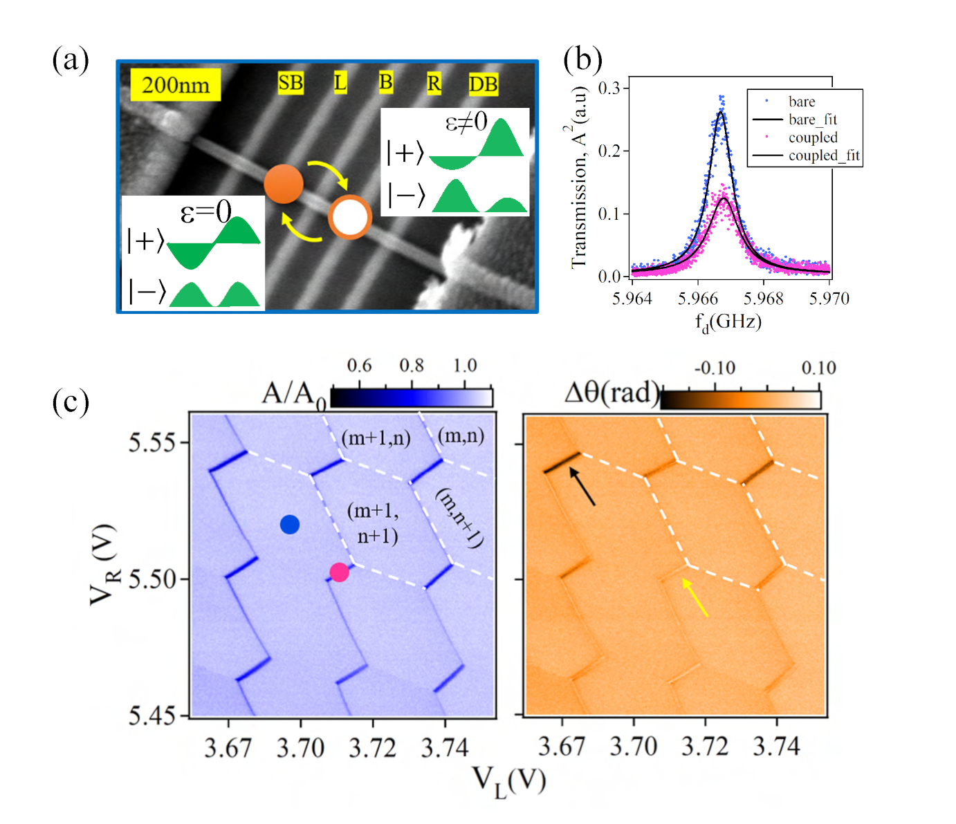

Fig. 14. Charge stability of a Ge/Si nanowire double quantum dot probed by the response of resonator transmission. (a) An image illustrating the formation of a double quantum dot working with different detuning $ε$ conditions. (b) Comparison of the resonance transmission spectra with $ε=0$ (resonant tunneling between dots) and $ε≫0$ (deep Coulomb blockade), corresponding to blue and red dots in (c) respectively. (c) Magnitude and phase variation of the transmitted signal as a function of $V_{L}$ and $V_{R}$. Indices $m/n$ in left panel indicate the respective charge number in the left/right dot. The voltage sweeping range covers a 3×3 charge stability diagram. The arrows in the phase plot (right panel) highlight the coexistence of negative and positive signal. $V_{SB}=4.3$ *V*, $V_{B}=7.145$ *V*, $V_{DB}=3.5$ *V*, and $V_{sd}=0$ *V*. Reprinted with permission from Ref. [13]. Copyright 2019 American Chemical Society.

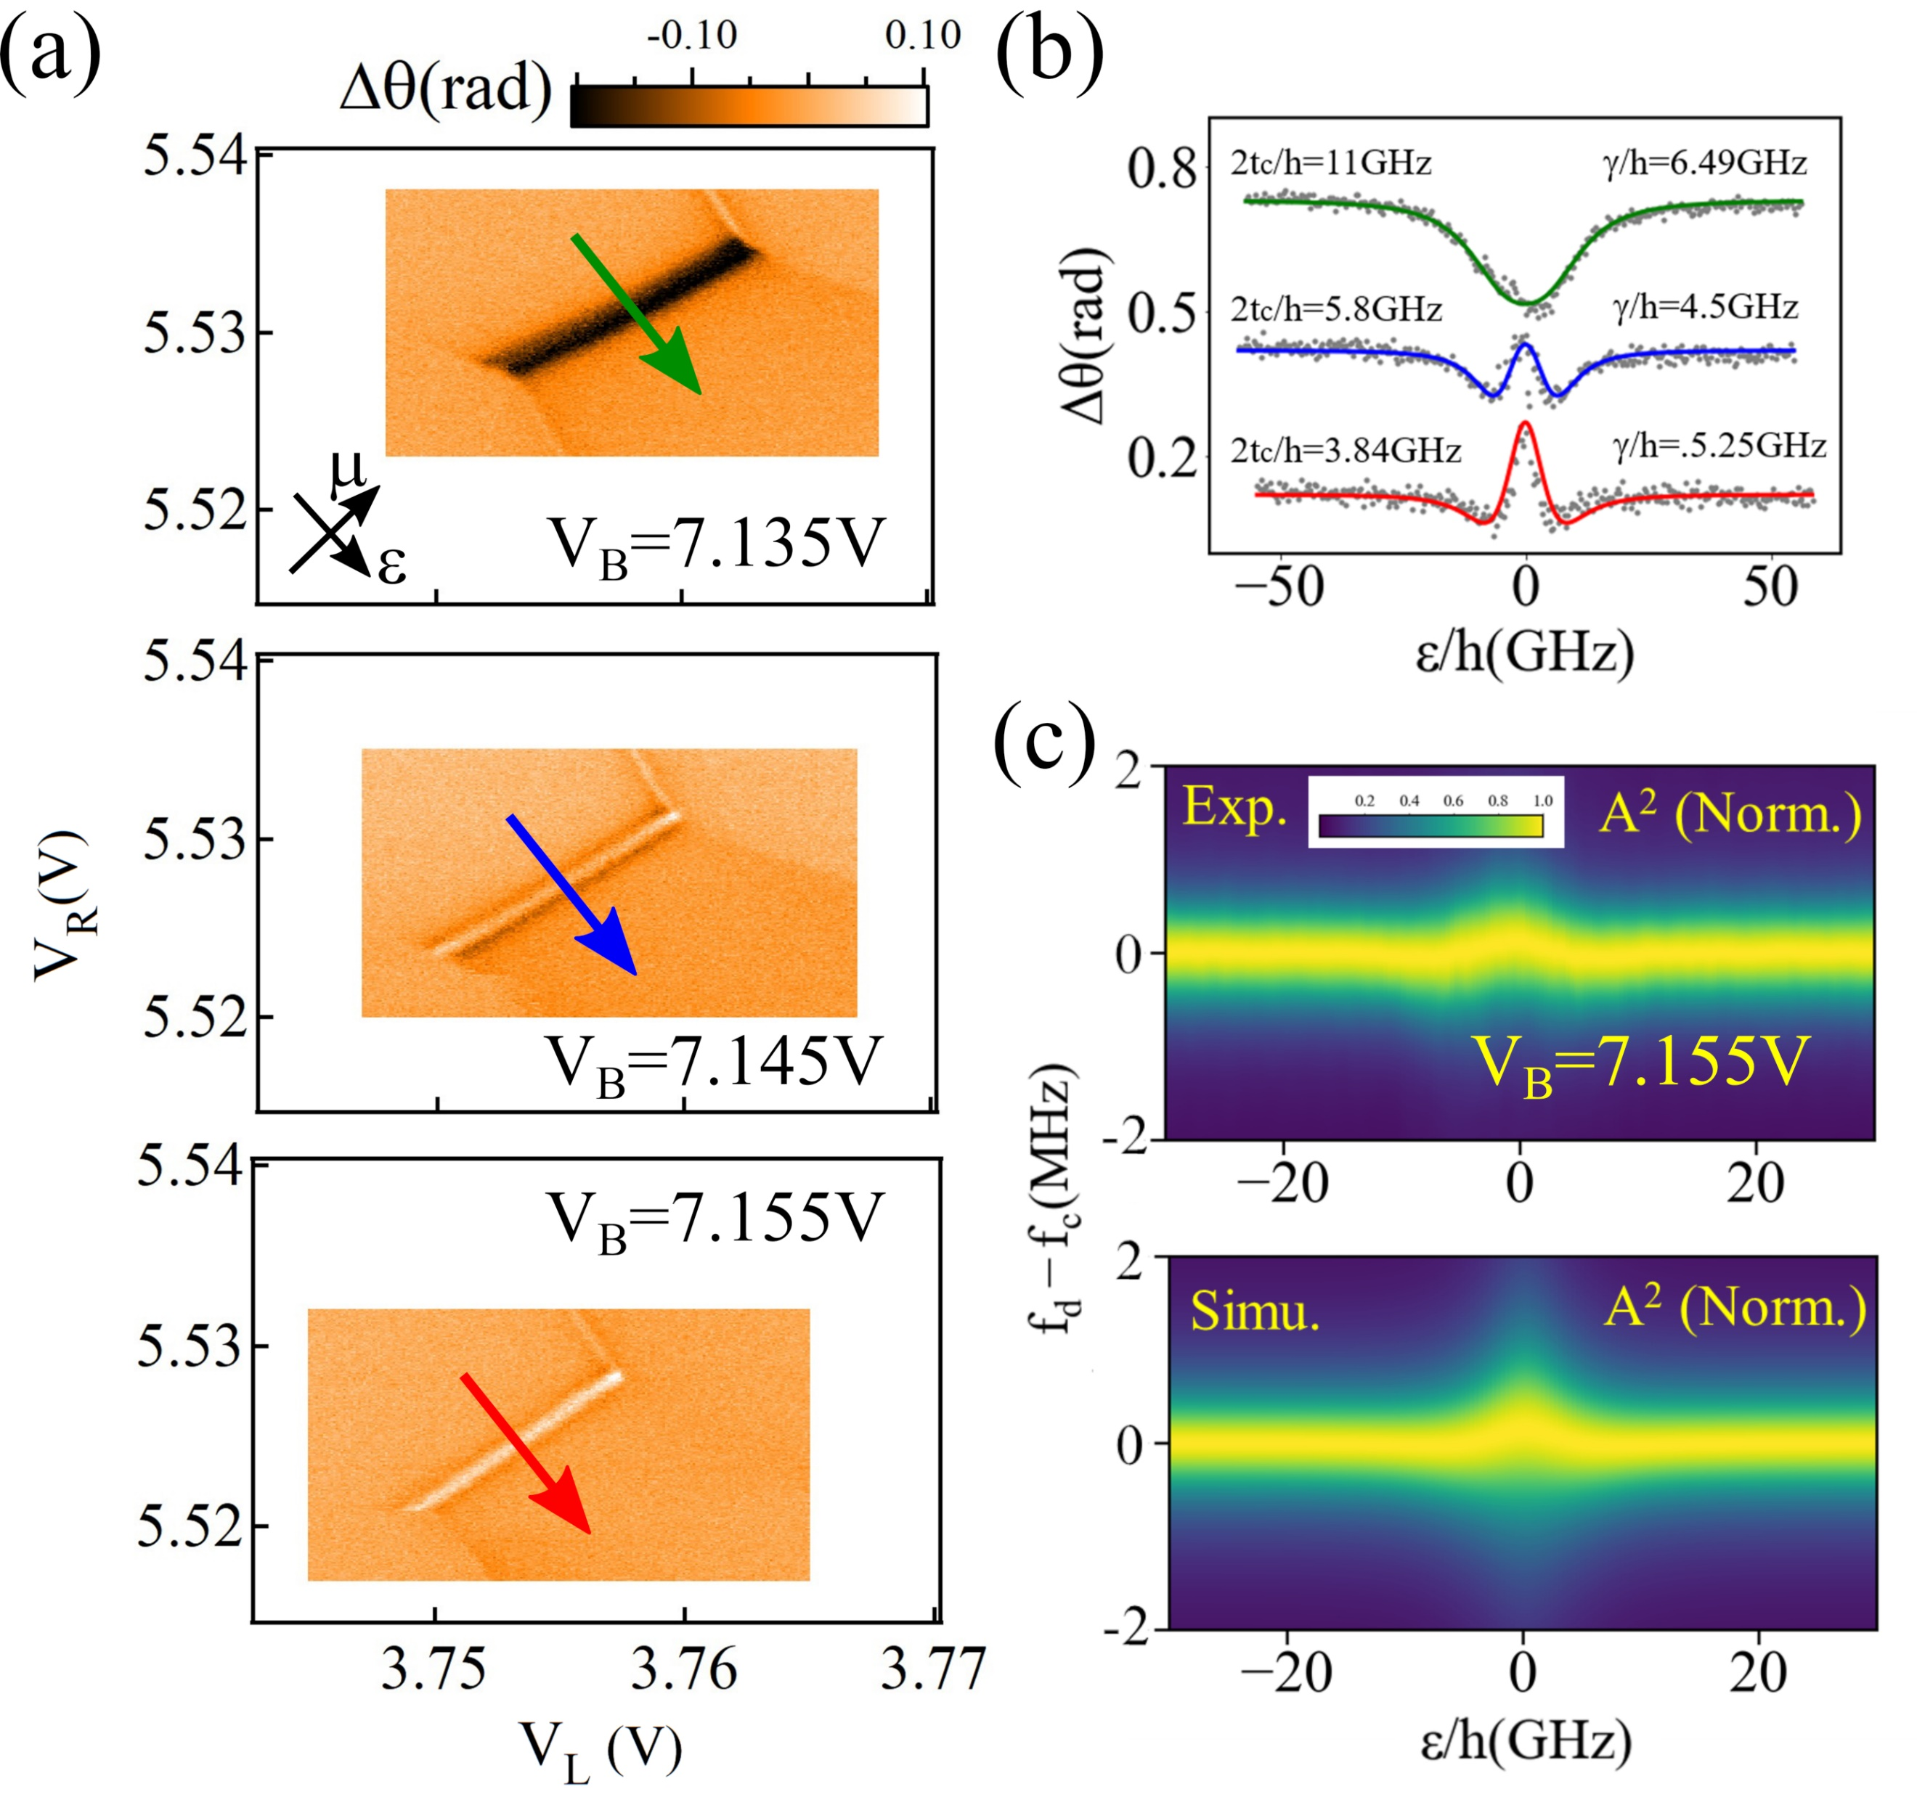

**Fig. 15.** Tuning of the charge qubit energy and the qubit-resonator coupling by electrical gating. (a)Evolution of one inter-dot charge transition line for the same range of $V_{L}$ and $V_{R}$ at zero bias with different middle barrier voltages $V_{B}$. $μ$ is the mean electrochemical potential and $ε$ is the energy detuning. (b) Comparison of phase shift $∆$ as a function of $θ$ with different $V_{B}$. (c) Comparison of experiment and numerical simulation of full transmission spectrum as a function of $f_{d}$ and $ε$ with $V_{B}=7.155$ *V*. Reprinted with permission from Ref. [13]. Copyright 2019 American Chemical Society.